The University of Rhode Island
Capstone Design I

Highway Safety: Flashing Lights
“Optimizing emergency lighting of highway patrol cars to prevent phototaxis and accidents; getting your attention without distraction.”

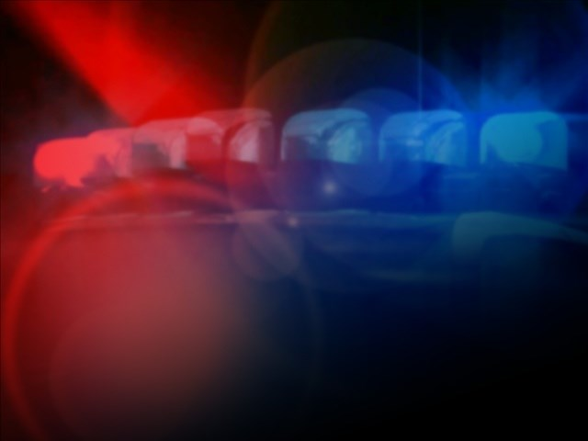
Image Credit: abc6.com

By
Anthony Ovalles
Raul Chacon

Table of Contents

Acknowledgements………………………………………………………………………….5
Project Description…………………………………………………………………………..6
Project Summary…………………………………………………………………….6
Motivation for Project……………………………………………………………….7
Project’s Current Status……………………………………………………………...8
Functional Specifications…………………………………………………………....9
Test Plan…………………………………………..…………………..……………..13
Setup Test……………………………………………………………………13
Conduct Test…………………………………………………………………13
Analyze Results………………….…………………………………………..14
Report Results…………….…………………………………………………16
Full-scale Simulation……..…………………………………………………19
Conclusion…………………………………………………………………..21
Block Diagrams and Drawings…….………………………………………………..22
Blueprints for Lights……….………………………………………………..23
Computer Simulation……….……………………………………………….32
Light Configurations………………………………………………………...32
Full-Scale Simulations……….………………………………………………33
Full-scale Design…………………………………………………………….33
Arduino Code………………………………………………………………..35
Whelen Edge Freedom Series Lightbar……………………………………..36
ABET OUTCOME C………………………………………………………………………..38
Major Milestones until December 14, 2015…..……………………………………………..39
Major Milestones for January to April 2016…..…………………………………………….40
Overall Linear Responsibilities Chart…………..…………………………………………...41
Summary of My Technical Responsibilities……..…………...……………………………..42
My Individual Technical Contributions to-date…..…………………………………………43
References…………………………………………..……………………………………….44
Appendix A: Updated Gantt Chart…………………..………………………………………46

Acknowledgments
We, the Flashing Lights team, would like to extend our thanks Dr. Harish Sunak, Richards Davids, the URI College of Engineering, URI Health Education, URI Department of Computer Science and Statistics, Whelen Engineering, and the Wickford Police Barracks.

Dr. Harish Sunak - ELE 480 Capstone Director
Richard Davids - Flashing Lights Technical Director
Scott Potter - Whelen Engineering
Trooper Eric Jones - Wickford Barracks
Tom Crotty - Scituate Police Barracks
Professor Michael Piserchia - URI Department of Computer Science and Statistics
Sheila G. Mitchell, R.N - URI Health Education

Project Description

Project Summary
The purpose of the Flashing Lights project is to design, build and test both computer and full scale simulations of a highway patrol vehicle light bar package that optimizes attention without distraction. Since there are many types of emergency lighting on public safety vehicles, we limit our project to investigate emergency lighting used by stationary highway patrol cars stopped on the right-side highway shoulder during a traffic stop. This situation is when most rear end accidents occur.

During our first semester research phase, we investigated human eye functions, the effects of dark adaptation, sensitivity of the eye to various wavelengths, and most importantly the phenomenon called phototaxis (also known as Moth-to-flame effect). We also investigated accidents caused by flashing lights in New England and developed a prototype computer simulation. We interviewed authorities in law enforcement about various types of emergency situations and lighting. In addition, we investigated the traditional ways emergency vehicle light bars are configured in Rhode Island (all red), Massachusetts (all blue) and Connecticut (red and blue) in order to compare them against other variations of light configurations during our simulations. We also looked into variations all over the United States and around the world, particularly Europe.

One of our primary goals is to determine the degree of distraction caused by emergency vehicle lights. In order to determine distraction quantitatively, we needed to find a way to track the eye movements of the driver and calculate whether there is a significant delta (difference in) time from when the driver identifies the emergency vehicle lights to when the driver refocuses attention to the road. We researched affordable and effective ways to do so using either an existing eye tracking device or a smartphone application. We eventually found an eye tracking device by Eye Tribe with accompanying software

For the second semester simulation phase, we will test human subjects in both a classroom computer simulation of flashing emergency lighting and a simulated driving environment to down select from 10 configurations to 3 or 4 configurations. We will be manipulating permutations of wave length (blue, red and white light) as well as frequency, intensity and flash pattern. We will then test those optimal configurations determined in the computer simulations using a full-scale Whelen Legacy Lightbar.

Motivation
Our visual environment is filled with flashing lights from school buses, public utility trucks and most emergency vehicles. The apparent purpose of all these flashing lights is to attract our attention. However, they can be distracting and confusing. There are a many different flashing light configurations used by emergency patrol cars depending on many factors including whether they are in transit or stationary. Different countries and even different states and regions use their own light configurations based on tradition or preference; there is no standardized configuration. Many people experience the phenomenon called phototaxis or moth effect (‘moth to the flame’). By attracting a driver’s attention, flashing lights contribute to errors in judgment of distance and location of the source of flashing lights (looming), resulting in rear end collisions and fatalities. Other potential hazards include glare (which can be exacerbated by eye glasses, windshields, rain, etc.) and photosensitive epilepsy (can be triggered by lights flashing at 10-20 Hz, regardless of color).
Many studies like this one have been conducted, like the Loughborough University study conducted in 2000 in the United Kingdom. In this study, participants were observed reacting to different light configurations and were then asked about their preference. Studies like this one are very subjective and lack objective data that may be able to persuade legislation to standardize emergency vehicle lighting. We hope to collect both objective and subjective data using our highway awareness simulations, participant surveys and eye tracking software.
The academic motivation behind this project is to apply our skills gained at the URI College of Engineering to a project that has real life implications, especially one which involves public safety and human life. This project will help us learn how to conduct a research experiment, develop better interpersonal and communication skills, and obtain a greater understanding of human perception and limitations.

Current Status
We have completed all four phases of the Highway Safety: Flashing Lights project. We will be presenting our results in this final progress report as well as on Friday, May 13, 2016 in Kirk Auditorium to Dr. Sunak, Rick Davids and the our fellow Senior Capstone Design classmates. We were unable to find a media platform to present our results, but we hope that our Technical Director would be able to continue this project in the future.

Functional Specifications

Eye Tribe Eye Tracker
The Eye Tribe Tracker will be used in our experiment to keep track of our subject’s eye movements during our computer simulation. This will be useful in keeping track of the subject’s eye movement and where they are looking when driving. As well as give us a good time on target for the subjects. The premise is that if the subject (driver) is distracted and looking at the flashing lights, then they will not see critical driving cues like road signs, directions, etc., in front of them. We intend to present subjects with traffic information and then ask them to recall if they saw that critical information. The eye tracker will provide the objective evidence of what the driver was seeing when different configurations of flashing lights are presented.

Below are the detail specifications:

Sampling Rate | 30Hz and 60Hz mode
Accuracy | 0.5° - 1°
Spatial Resolution | 0.1° (RMS)
Latency | <20ms at 60Hz
Calibration | 9, 12 or 16 points
Operating Range | 45cm - 75cm
Tracking Area | 40cm x 30cm at 65cm distance (30Hz)
Screen Size | Up tp 24”
API/SDK | C++, C#, and Java included
Data Output | Binocular gaze data
Dimensions (W/H/D) | 20 x 1.9 x 1.9 cm (7.9 x 0.75 x 0.75 inches)
Weight | 70g
Connection | USB 3.0 Superspeed

Unreal Engine 4
Unreal Engine 4 is a complete suite of game development tools made by game developers, for game developers. One of its key features that attracted us to this software was the real-time global illumination using voxel cone tracing, which eliminated pre-computed lighting. This gave us the flexibility we needed to develop a realistic scenario involving a driver on the highway at night approaching a stopped emergency vehicle.
Below are its hardware and software specifications:
Operating System | Windows 7/8 64-bit
Processor | Quad-core Intel or AMD, 2.5GHz or faster
Memory | 8GB RAM
Video Card/DirectX Version | DirectX 11 compatible graphics card
Operating System | Windows 7/8 64-bit
DirectX Runtime | DirectX User runtimes (June 2010)
All “Running The Engine” Requirements | (automatically installed)
Visual Studio Version | Visual Studio 2013 Professional or Visual Studio 2013 Community
iTunes Version (iOS development) | iTunes 11 or higher

PC
The PC will be running Unreal Engine 4 to simulate the different light configurations for the police cars. The PC will be mainly used for the side-by-side comparison test and the driving simulation, since it has the required specifications to run the simulation with the best rendering.

Processor | Intel Core i7 - 2700K CPU @ 3.50 GHz
Memory (RAM) | 16 GB
Graphics Card | AMD Radeon R9 380 Series
Dedicated Graphics Memory | 4096 MB
Operating System | Windows 7 64 - bit

Arduino Mega
The Arduino Mega is the microcontroller that will be used to power and program several light configurations in the Whelen Legacy Lightbar.

Microcontroller | ATmega2560
Operating Voltage | 5V
Input Voltage (recommended) | 7-12V
Input Voltage (limit) | 6-20V
Digital I/O Pins | 54 (of which 15 provide PWM output)
Analog Input Pins | 16
DC Current per I/O Pin | 20 mA
DC Current for 3.3V Pin | 50 mA
Flash Memory | 256 KB of which 8 KB used by bootloader
SRAM | 8 KB
EEPROM | 4 KB
Clock Speed | 16 MHz
Length | 101.52 mm
Width | 53.3 mm
Weight | 37 g

Whelen Legacy DUO Series Lightbar
Whelen Engineering will be allowing us to use their new Legacy lightbar for experimental purposes. Whelen Engineer Scott Potter will be delivering the product and giving us a more detailed presentation its functional specifications. The following product specifications have been taken from their website:
http://www.whelen.com/auto/product?head_id=4&cat_id=147&prod_id=617

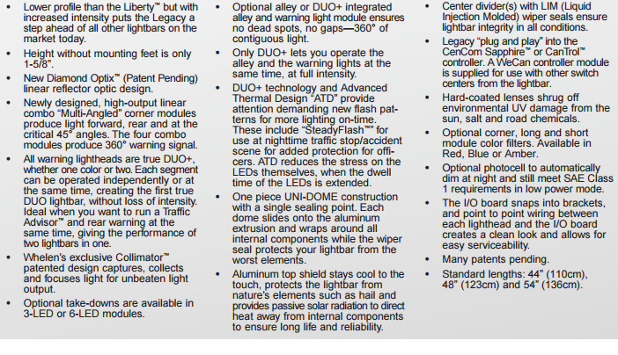Power Control Center (Model No. PCC10W)
The PCC10W came with the lightbar we borrowed from Whelen Engineering. It is attached to a control module which can be programmed using Whelen Engineering’s custom light bar editing software, WeCan 6.

The PCC10W incorporates ten 25 amp rocker switches installed in a steel black powder coated epoxy chassis and housing. The ten rocker switches are installed in a ten position fuse box chassis with each rocker switch plugged into a PCB board. Each rocker switch will contain a red LED that illuminates when the switch is turned on.

Voltage: +12 V Size (Excluding Mounting Option): H=2.25”, W=5.80”, D=3.59” Amp Draw: 25 Amps per Switch

Test Plan

Setup Test
For this experiment we will need to gather subjects of diverse age groups and backgrounds for both the computer and full scale simulations. Many of our subjects will probably be our classmates and professors, but we need to reach out to the community to try and get a large and diverse group. If we obtain a large group then we can use parametric statistical analysis (means, normal distribution, etc.) However, nonparametric statistical analysis (medians, ordinal or nominal data, etc.) can be used in case our sample size is fairly small (less than 20).
Once we have gathered a group of subjects for our experiment, we can then proceed to set up our computer simulation. The simulation will take place in a dark classroom ( Kelley Hall basement). According to Encyclopedia Britannica, the human eye takes approximately 20–30 minutes to fully adapt from bright sunlight to complete darkness and become ten thousand to one million times more sensitive than at full daylight. However, we do not want volunteers to feel agitated or tired during our experiments so for the purpose of this experiment the wait time will be 10 minutes. We are considering using a Luminous Flux meter (Lux meter) to measure the light output in lumens in the dark room. While our subjects are waiting, we will be setting up the hardware in a separate room.
The hardware setup will consist of connecting the tracker to the PC and positioning the eye tracker below the monitor. A calibration for the eye tracker will be done for each subject to make sure their eyes are being properly tracked.

Conduct Test
The first test that will be conducted is the computer simulation paired comparison test. We will display several predetermined light configurations to the subjects one-by-one, similar to an eye exam. The paired comparison test will be conducted on the PC and the Unreal Engine.
The second test will be a driving simulation conducted using the PC as well and will allow the subject to drive down a road at night, a police car, with varying light configurations, will be placed on the right side of the road, several hundred yards away. The simulation will be a virtual version of driving on the highway, so the subjects will experience the lights getting closer and brighter as they approach them. We will also have several signs in the simulation. We will instruct the subjects to recall the color of the signs to us to test whether or not they are paying attention to the road. The eye tracker will be keeping track of the subjects eye movements to test the subject’s time-on-target (the road).
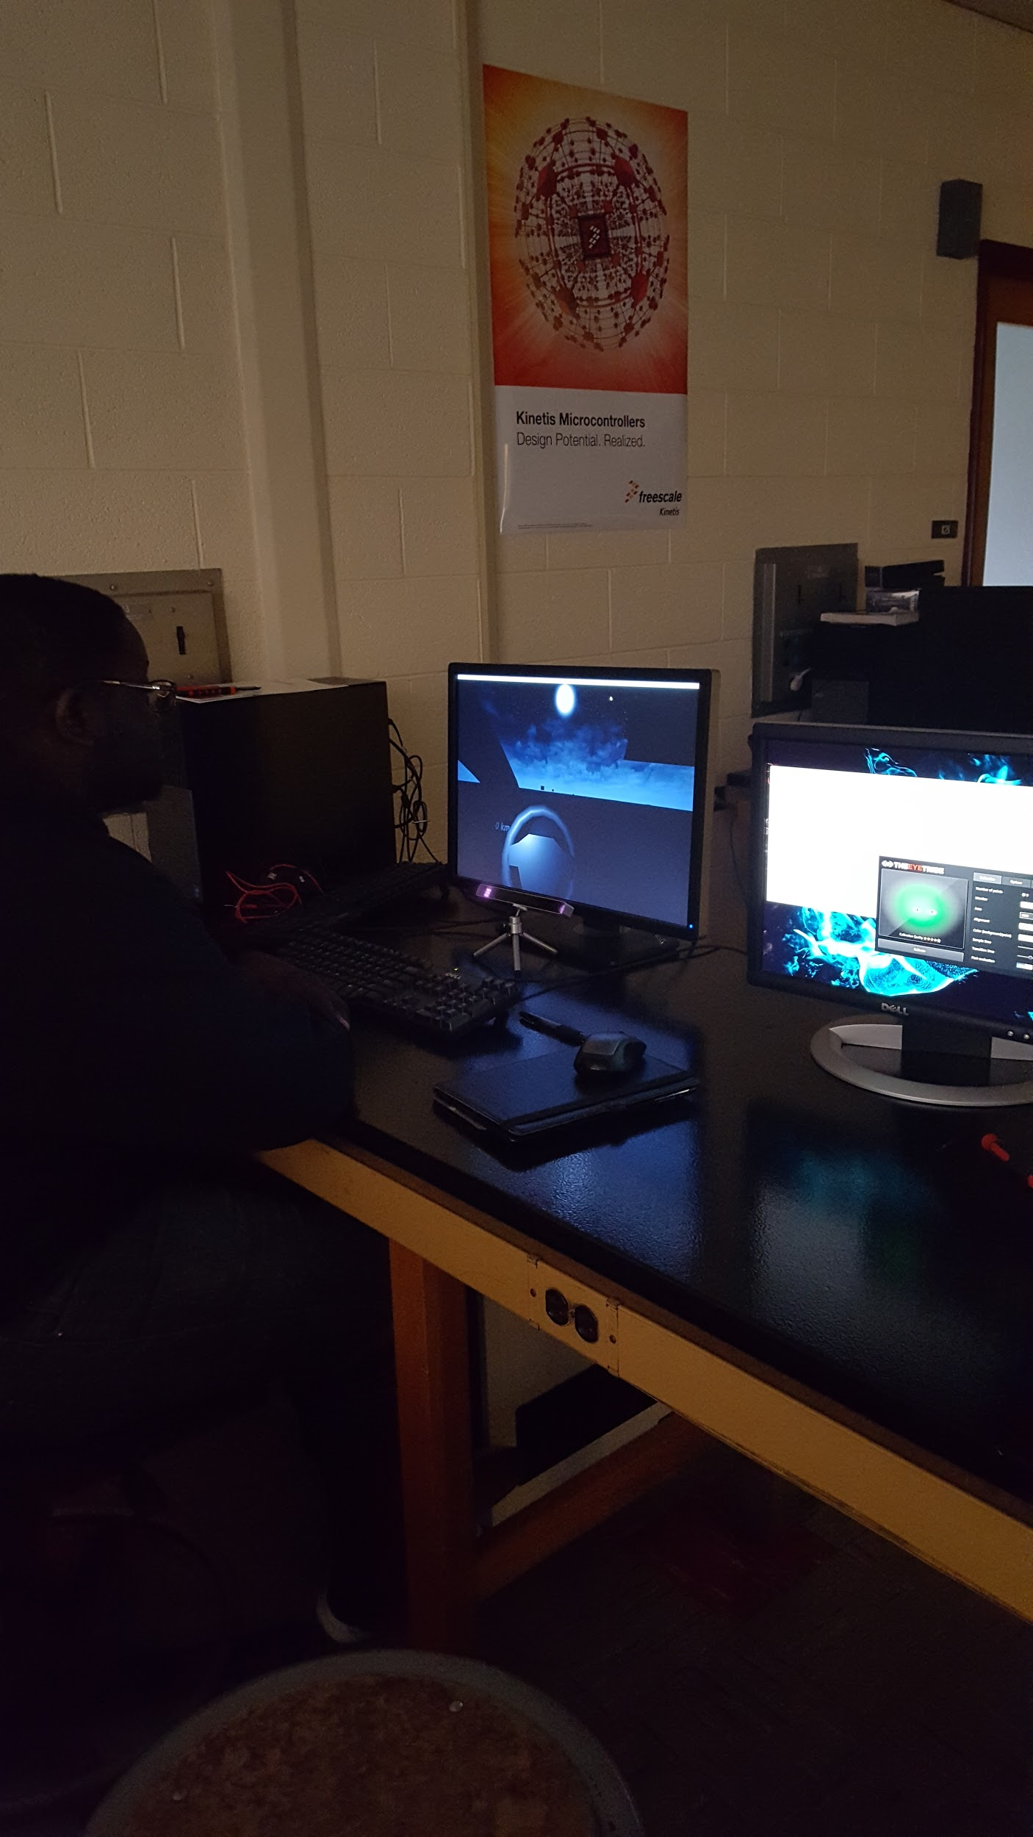
Highway driving simulation set-up

The results of the highway driving simulation will then help us determine a plan for our high fidelity full-scale simulation.

Analyze Results
For the purpose of time and efficiency, we will be integrating the paired comparison test with the computer simulation. Volunteers will be asked to rank each configuration on the Likert scale (0 Least Distracting - 5 Most Distracting). They will then be asked to compare each configuration against the other as shown in Table 1. This will offer us qualitative data for our study.
During the computer simulation, the eye-tracker will also be providing quantitative data. We are mainly concerned with tracking the time the volunteer is watching the road versus the time spent looking at the lights on the side of the road as shown in Table 2. This part of the experiment will offer quantitative evidence on the level of distraction caused by the light configuration. The purpose of the secondary tasks is to determine whether the light configuration affected the volunteers’ ability to read highway signs while driving. The details on the secondary tasks have yet to be determined.

Table 1: Sample for Paired Comparison
Subject | A-B | A-C | A-D | A-E | A-F | B-C | B-D | B-E | B-F | C-D | C-E | C-F | D-E | D-F | E-F
1
2
3
4
5

This table is an example of how we will be running the paired comparison test. As shown, we will be display multiple pairs of configurations to our subject. For example of the first pair of lights, subject 1 will see light configuration A, then they will be shown light configuration B. After seeing both light configuration, they will choose which of the two was less distracting. That process would then continue for the rest of the pair of light configurations.

Table 2: Sample Computer Simulation
Subject | Time on Target | Time on Lights | Construction Sign | Exit Sign | Accident Ahead | Speed Limit
1
2
3
4
5

For the computer simulation, subjects will be sitting in front of a computer screen and be shown a simulation of driving on the highway. There will be emergency vehicle lights stopped on the right side of the road, a couple hundred yards away. As the car approaches the lights, it will pass through four highway signs. We will observe the amount of time the subject will be observing the road vs. amount of time they are observing the emergency vehicle lights using the Eye Tracker. After the driving simulation is over, we will ask the subject to tell us if they saw any highway signs and ask them to describe what they were.

Report Results
As expected from the start of our project, we were unable to gather enough public interest. We managed to find fifteen diverse subjects to participate in the three experiments (five for each). Each subject filled out a questionnaire prior to the experiment. When they completed the short questionnaire, we provided the instructions for the experiment.

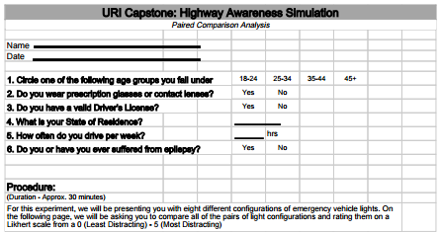
Figure 1: Sample Questionnaire for Paired Comparison Test

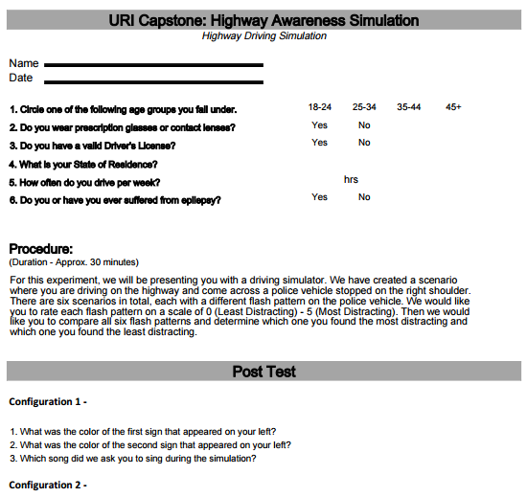
Figure 2: Sample Questionnaire for Highway Driving Simulation
For the paired comparison test, subjects were ask to compare all of the configurations against one another on the following table:

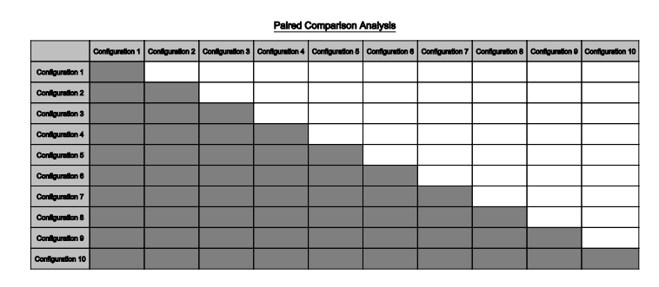
Figure 3: Sample Paired Comparison Chart

We gathered all of our results and created a bar graph with the likert score on the y-axis and the configuration number on the x-axis.

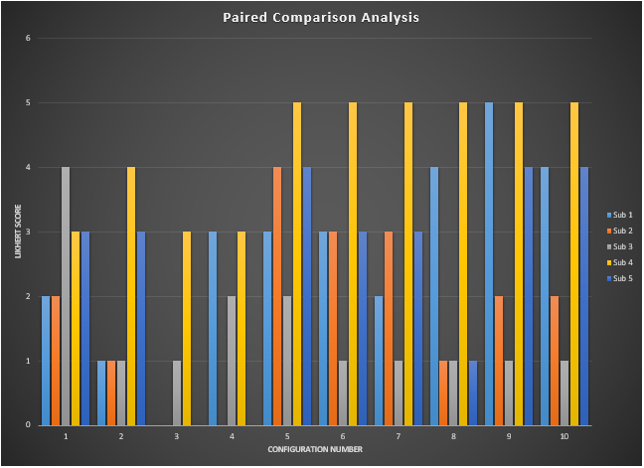
Figure 4: Paired Comparison Analysis

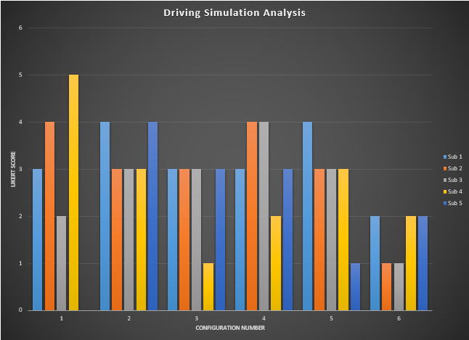
Figure 5: Driving Simulation Analysis

From these results, we observed that all of the subjects preferred Configurations 3 and 6 of the paired comparison test and the driving simulation, respectively. Both of these configurations were low intensity, blue wig-wag (hand-waving) lights. However, because of the low number of subjects used for the experiment, this data is inconclusive.

The following data is what we recorded with the eye-tracking software:

Table 1 - Eye Tracking Data
Configuration | Subject 1’s Time* | Subject 2’s Time* | Subject 3’s Time* | Subject 4’s Time* | Subject 5’s Time*
1 | 1.5s / 16s | 1.6s / 19s | 1.5s / 21s | 1.4s / 19s | 4s / 22s
2 | 2.5s / 12s | 2.1s / 18s | 1.6s / 21s | 2.5s / 20s | 2.2s / 22s
3 | 3.4s / 18s | 1.8s / 18s | 1.4s / 18s | 0.9s / 18s | 1.9s / 18s
4 | 1.2s / 17s | 1.5s / 20s | 5.6s / 24s | 0.8s / 14s | 1.3s / 22s
5 | 0.5s / 18s | 1.3s / 18s | 1.0s / 16s | 1.1s / 22s | 6.9s / 22s
6 | 0.4s / 14s | 0.9s / 16s | 1.3s / 14s | 0.9s / 16s | 3.3s / 16s

* Time off Target over total time recorded. The total time may vary for some configurations based on time it took to start recording new data and start the next configurations

We are able to gauge whether a subject is irritated by the flash pattern in the simulation by tracking their eye movements. The simulated police vehicle was positioned on the right of the screen. If we saw the subjects eyes move towards the right of the screen and then quickly back towards the center (the road), then we knew that the flash pattern was conspicuous enough to catch their attention but not enough to distract them from the road. On the other hand, if their eyes moved towards the police vehicle and then off the screen or they closed their eyes, then we determined the lights were very irritating and caused the subject to be distracted from the road. In this case, we saw that Configuration 1 (flashing red and blue lights) caused all subjects the most irritation, while Configuration 6 (low intensity, steady flash) caught their attention but did not distract them from the road.

Our secondary task was to have the subjects remember the color of the signs on the left side of the road for each configuration (i.e. red, blue, green, yellow). Our hypothesis was that the more distracting the emergency vehicle lights were, the more difficult it would be to recall small details like the color of the road signs. From our experiments, we saw that ⅗ subjects were unable to recall the color of the signs in Configuration 1. In contrasts, all five subjects were able to recall the color of the signs in Configuration 6. However, once again, because of the low number of subjects for our experiment our data inconclusive.

Full-scale Simulation
The Full-scale simulation was conducted on East Alumni Ave. Volunteers were directed to drive out of the Kelley Hall parking lot, turn right, and drive down the road towards our full-scale light bar. Our light bar was positioned on the sidewalk 200 feet from the parking lot, on a 48 in. tall cart. This accurately simulates the lights on a 60 in. tall sedan-style police cruiser. After driving passed the light bar, we asked test subjects to pull over to the right side of the road, turn around and repeat the experiment for six configurations.
To optimally test our configurations, our experiments were originally designed to take place at night. However, due to scheduling conflicts, we conducted our experiments during the late afternoon in inclement weather (i.e. heavy rainfall).
For this experiment, we were unable to use the eye tracker because we could not find a way to keep it from moving inside the vehicle. This made it very difficult to calibrate it. Instead, we decided to have one of the experimenters sit in the vehicle with the subject and observe their reaction to seeing the configuration. When the test subject pulled over to the side of the road, they were asked to rate the level of distraction or irritation (0-5) they felt from the light configuration, as well as the difficulty of pulling over immediately after passing the light bar.

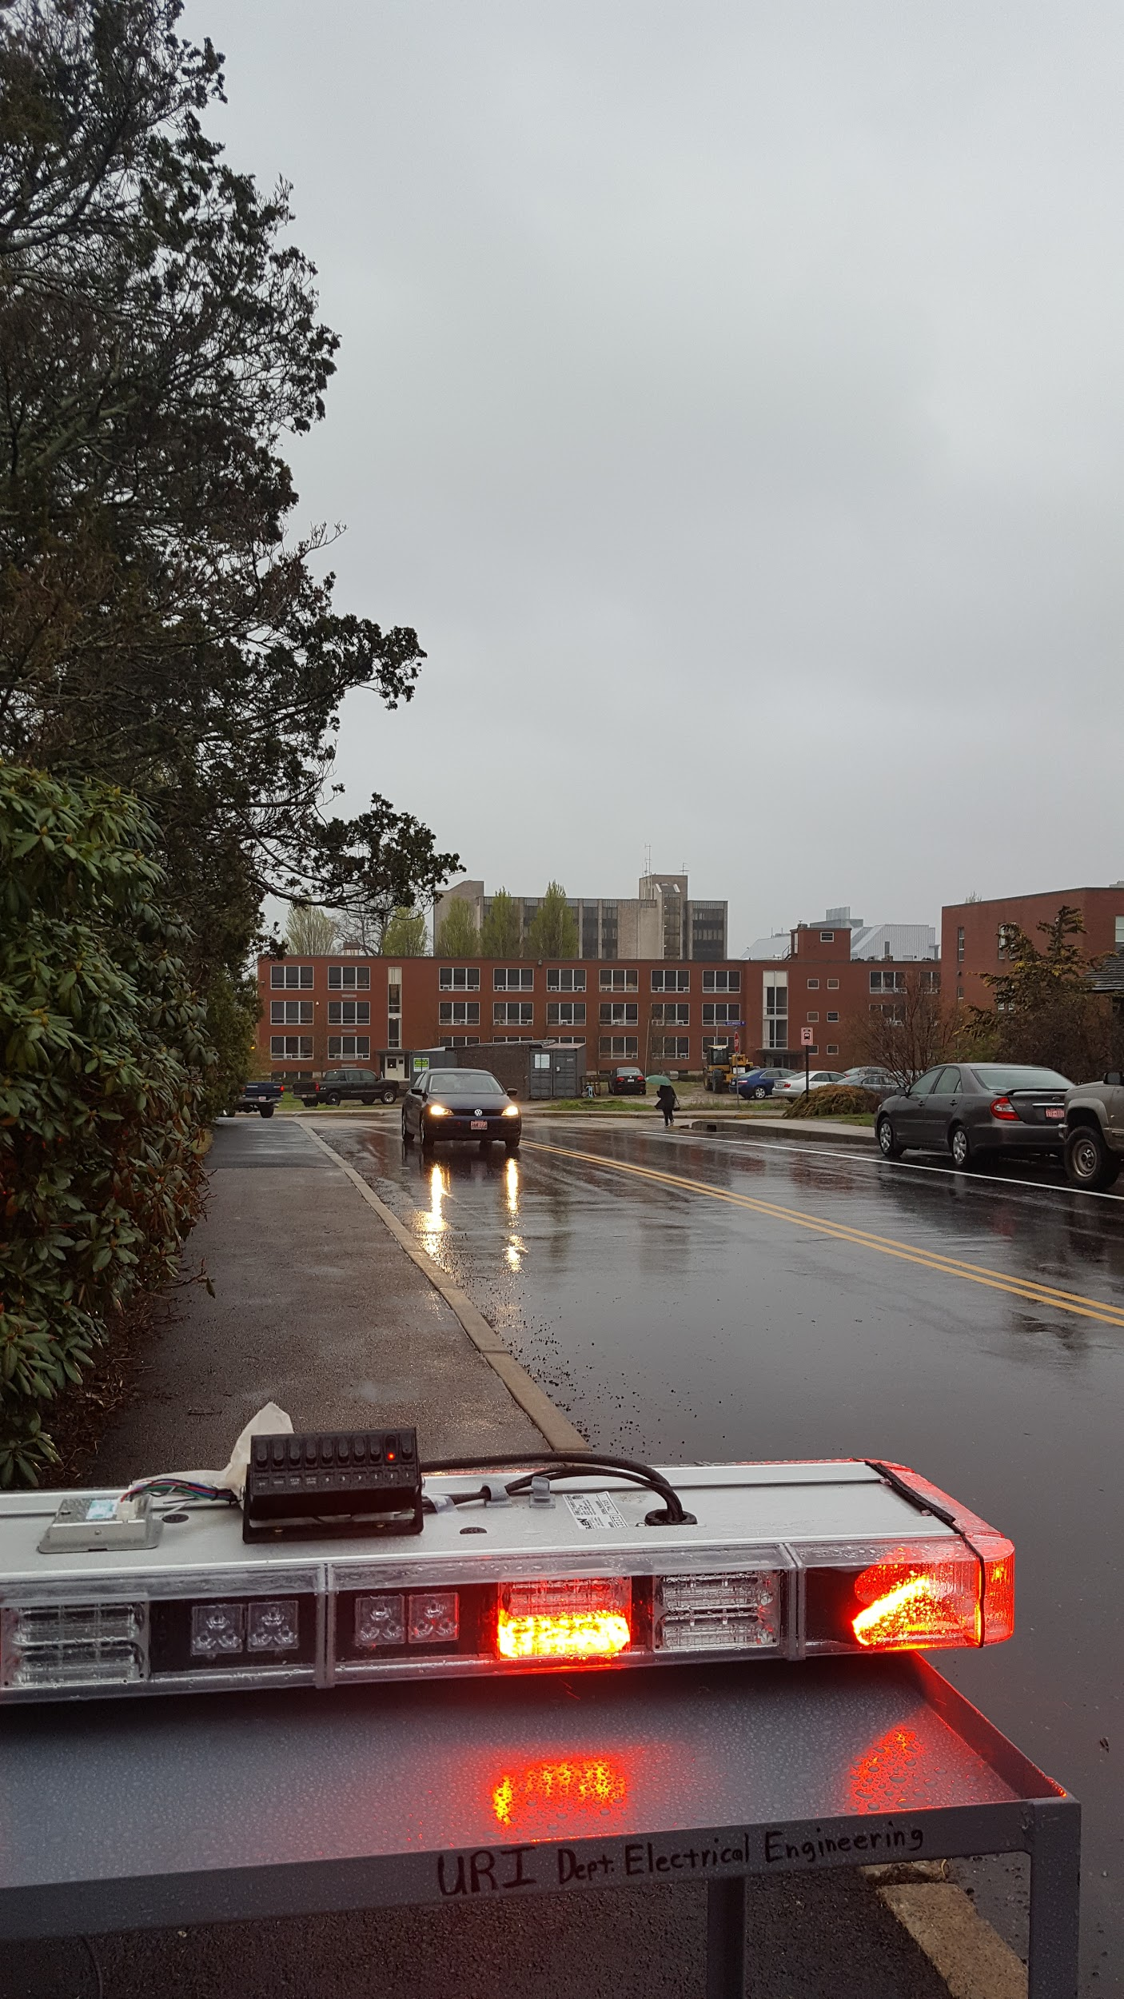
Figure 6: Full-scale simulation (street view)

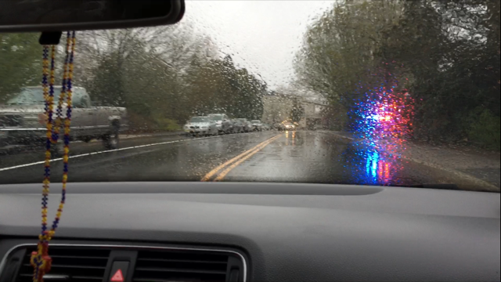
Figure 7: Full-scale simulation (Vehicle view)

Once again, we observed that all of the test subjects found the alternating red and blue lights to be the most distracting or irritating. In contrast with our other experiments however, we found that 80% of the test subjects found the red lights far more distracting or irritating than the blue lights. We also found that, similar to our other two experiments, all test subjects preferred the configuration with low intensity, steady flashing blue lights.

Conclusion
After three different experiments with a diverse set of test subjects and very similar results, we can conclude that low intensity, steady flashing blue lights are optimal for use when an emergency vehicle is parked on the right side of the road at night or in inclement weather. All three experiments were able to show that this light bar configuration was conspicuous enough to draw attention, but not distracting enough to cause the test subject to look away or be distracted by it. However, we saw no evidence of phototaxis. From tracking the eye movement of test subjects in the Highway driving simulation, we saw that all of the subjects were focused on the road and only looked at or away from the flashing lights. During our full-scale simulation we saw that some of the flash patterns caused the subjects discomfort and caused them to look away, but none of them ever moved towards the lights. The result may have changed if we did the experiments at night or if we had done the experiment on a road where subjects were allowed to drive at higher speeds.

Block Diagrams & Drawings

Setup Test
(Hardware setup, instruct subjects, record responses)

Conduct Test
(Computer simulation paired comparison, low fidelity road simulation, high fidelity full scale hardware test)

Analyze results.
(Parametric analysis if over 30 subjects otherwise non-parametric)

Report Results
(Reaction times, eye movements, etc.)

Provide Recommendations
(Color configurations, rise times, decay times, steady times, etc.)

Figure 1 - Block Diagram for each project phase

Blueprints for the Light Configurations:
The Blueprints for Configurations #1 and #4 are not shown due to the fact they are just solid, always on, lights.

Configuration #2
- All Blue lights
- Outer 4 lights flash and then the inner 4 lights flash
- Main Blueprint: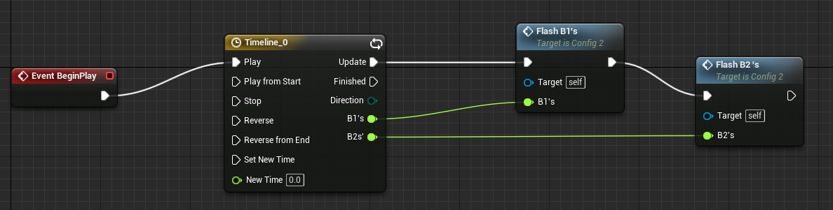

Configuration #3
- All blue lights with the outer 4 lights blinking while the inner 4 lights stay solid.
- Main Blueprint:
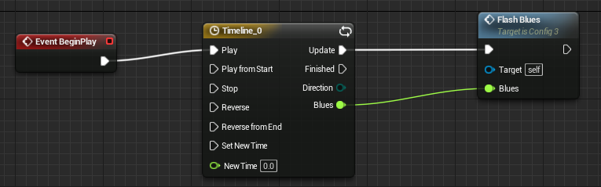

Configuration #5
- Alternating flash between 4 red lights and 4 blue lights
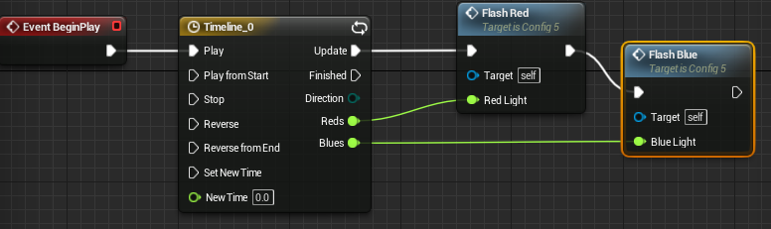
Configuration #6 & #7
- Lights up at the center of the bar in red/blue and moves outward
- The end lights blink twice quickly in the opposite color.
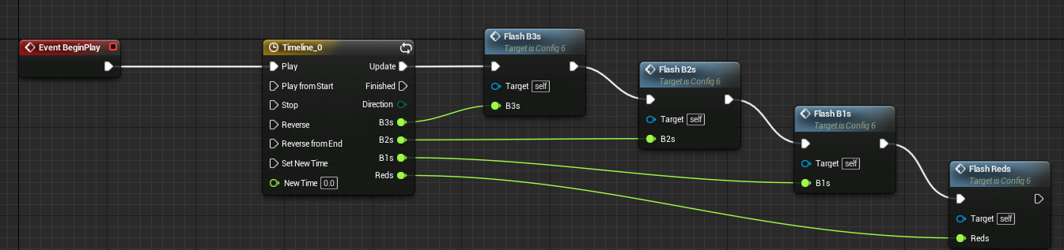

Configuration #8
- The ends flash red while the center 6 lights of the bar stay a solid blue
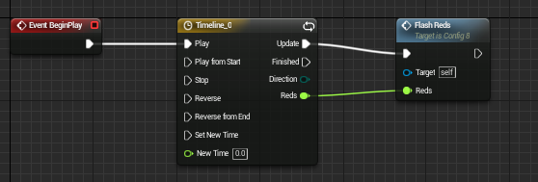
Configuration #9 & #10
- The bar lights up at one end and the light moves across the bar to the other end
- The light then repeats the process from the other end
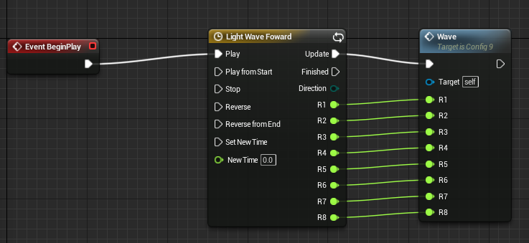

Functions
All the blueprints use the Flash functions which mostly the same. The differences between them are things like number of spotlights they are referencing and which spotlights they are referencing.
Examples:
Flash Bs - Used to reference 4 Blue Lights.
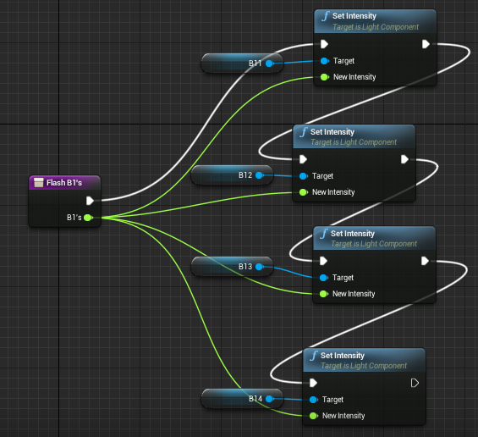
Flash B3s - Used to reference 2 Blue lights
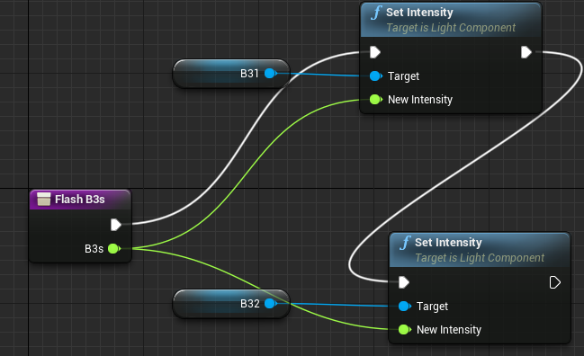

Timelines
One of the key features of the Unreal Engine’s visual program blueprint is the timeline function. It allows one to create a timeline that can alter an object over an amount of time. I used for many of the light configurations change the intensity of the lights from on to off.

- All the timelines are a Time vs Intensity of Light graphs
  - Time along the X - axis
  - Intensity of the lights along the Y - axis

- Timeline used for Configurations #2,3,5, and 8:
  - The graphs due vary a bit due to less or more lights being used
  - Time goes from 0 to 0.75s then loops
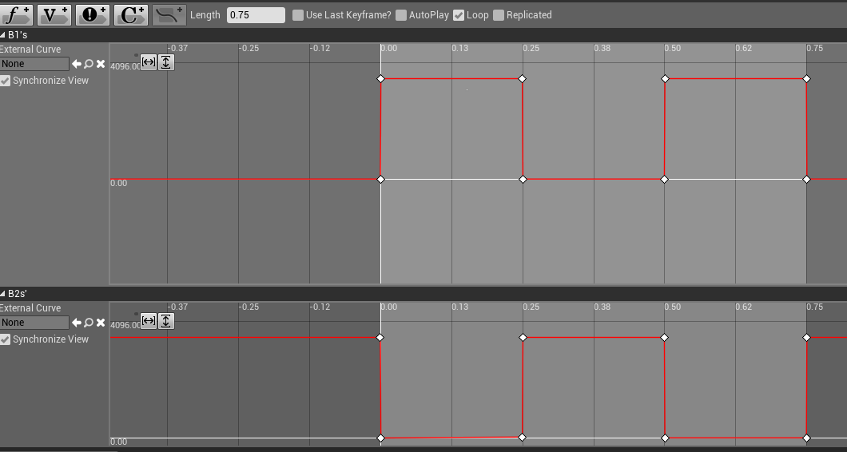

- Timeline for Configurations #6 and 7:
  - Due to scaling the scaling of the graphs may be seem off.
  - Time goes from 0 to 1.13s then loops
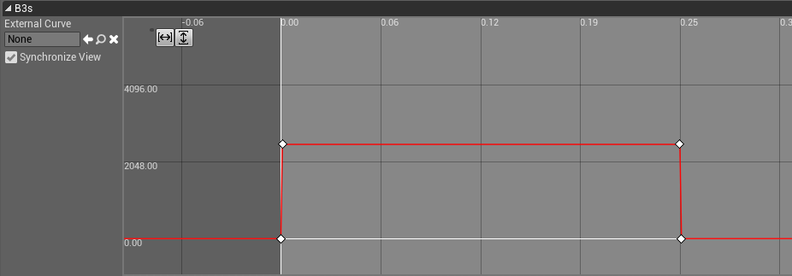
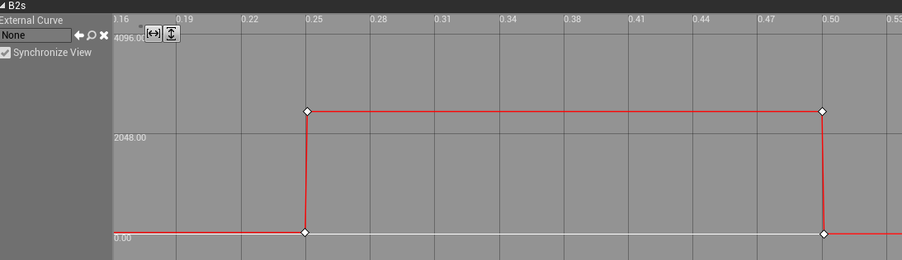
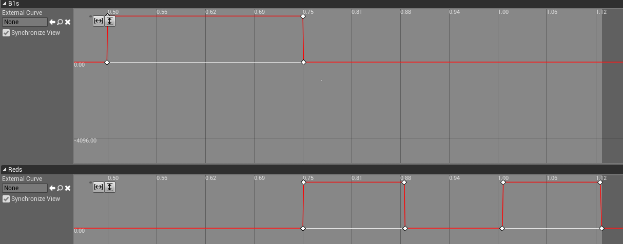

Timeline for Configurations #9 and 10:
  - Time goes from 0 to 4s then loops.
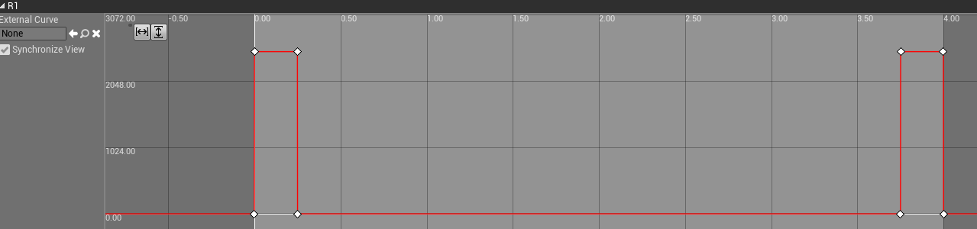
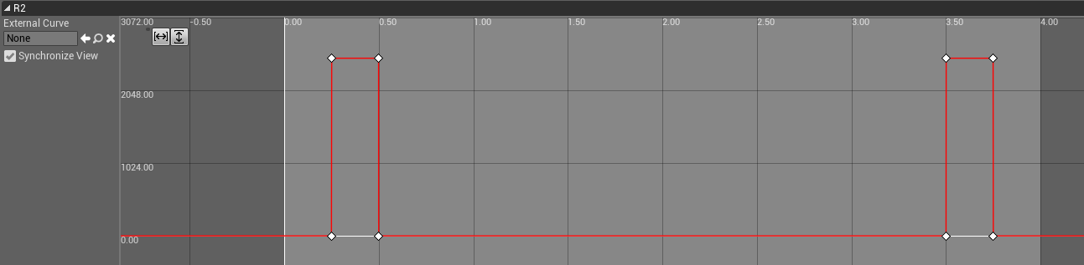
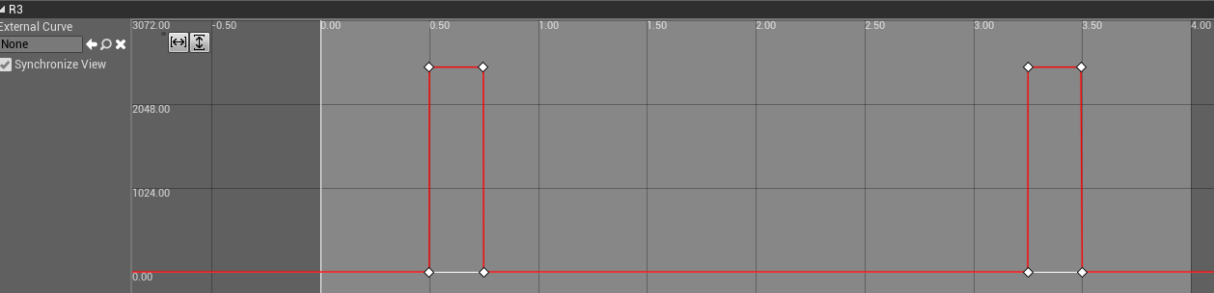
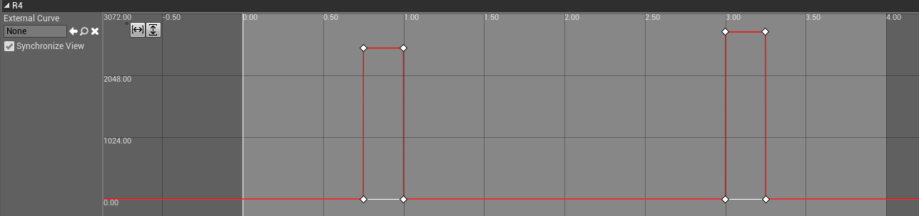
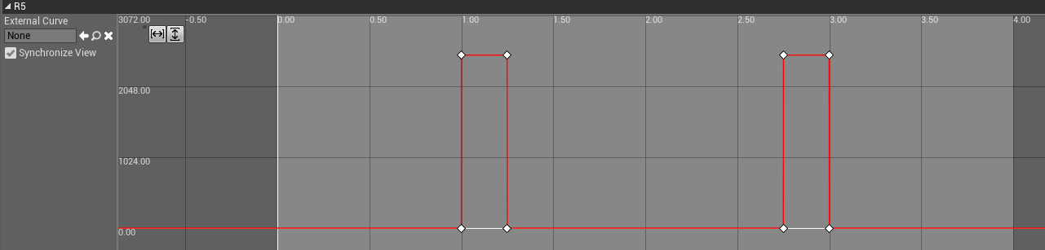
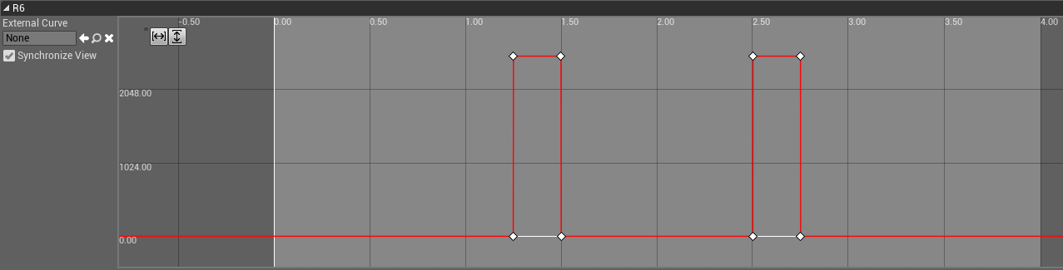
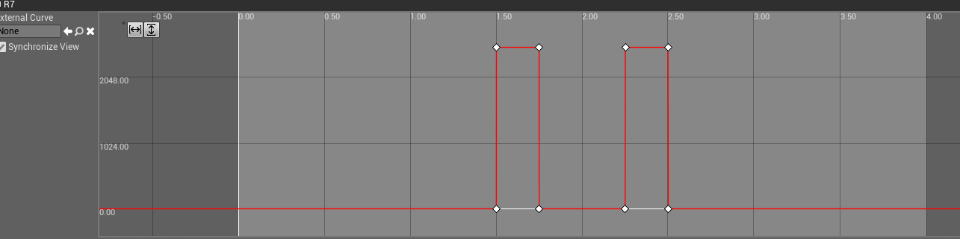
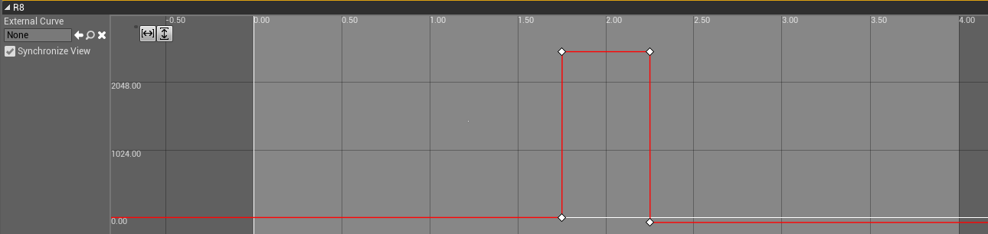

Simulation Screenshots
The following are some samples of the configurations created in Unreal Engine 4 using the functions described above:
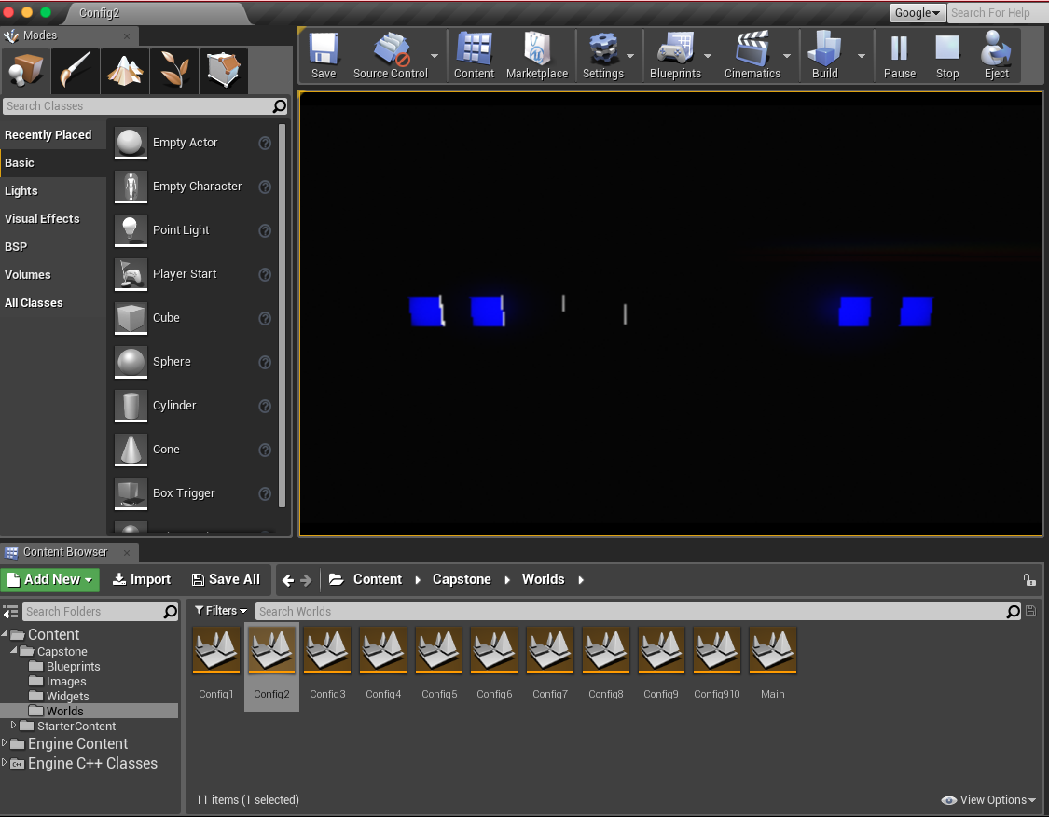
Paired comparison test: Alternating blue lights
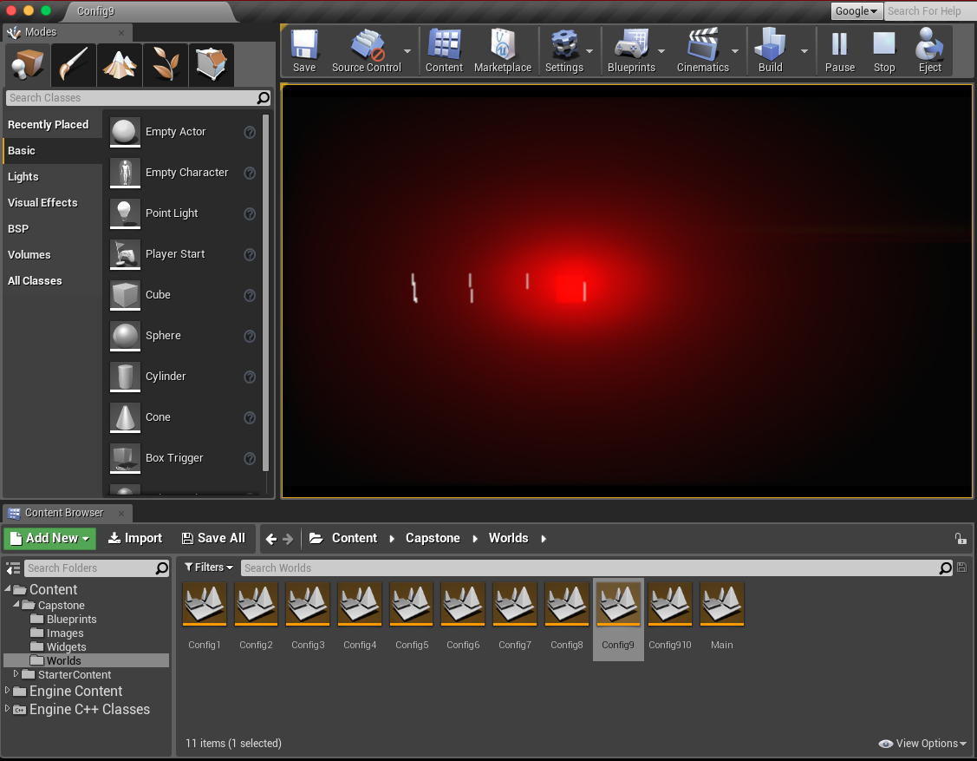
Paired comparison test: Strobing red light

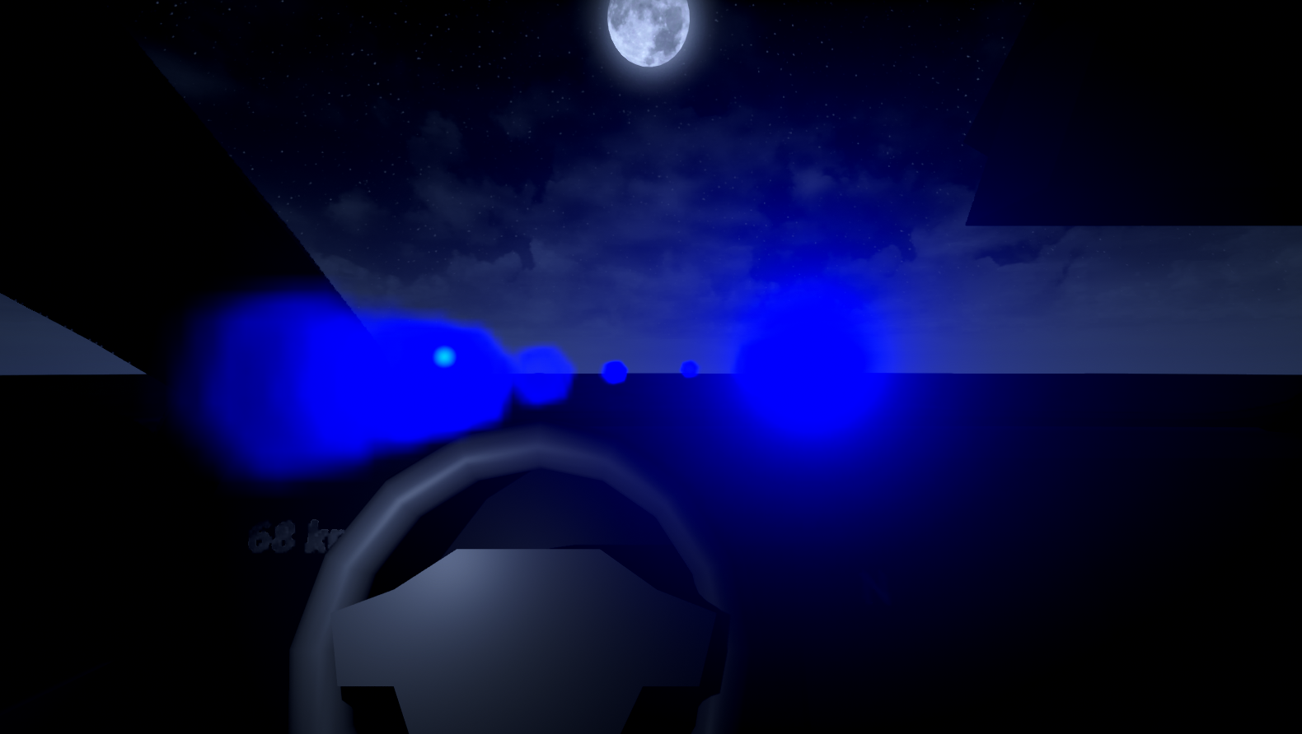
Highway driving simulation: Alternating blue lights

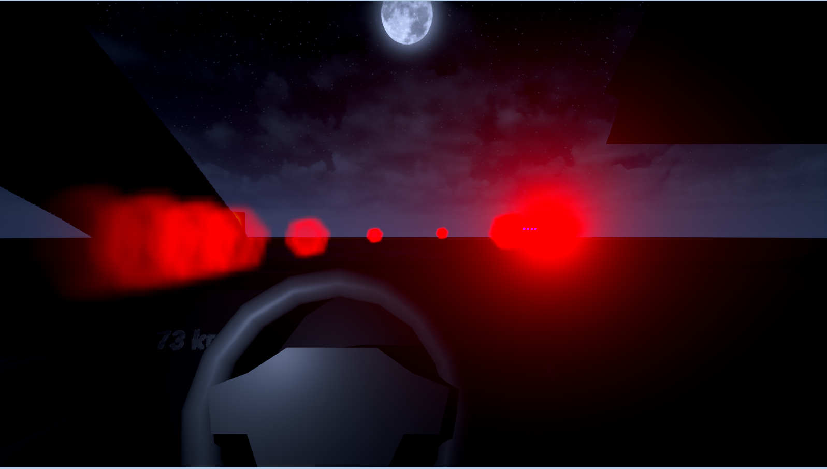
Highway driving simulation: Alternating red lights

Computer Simulation
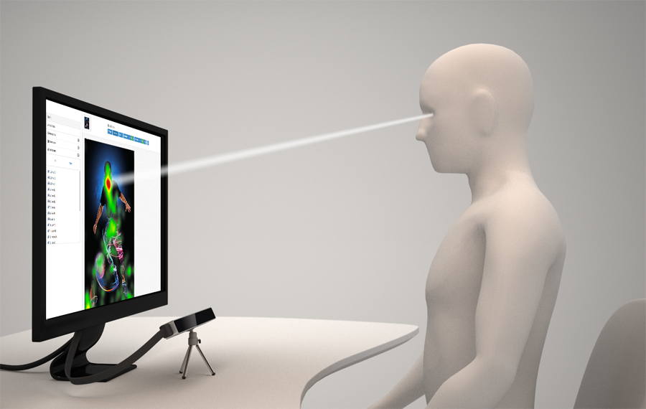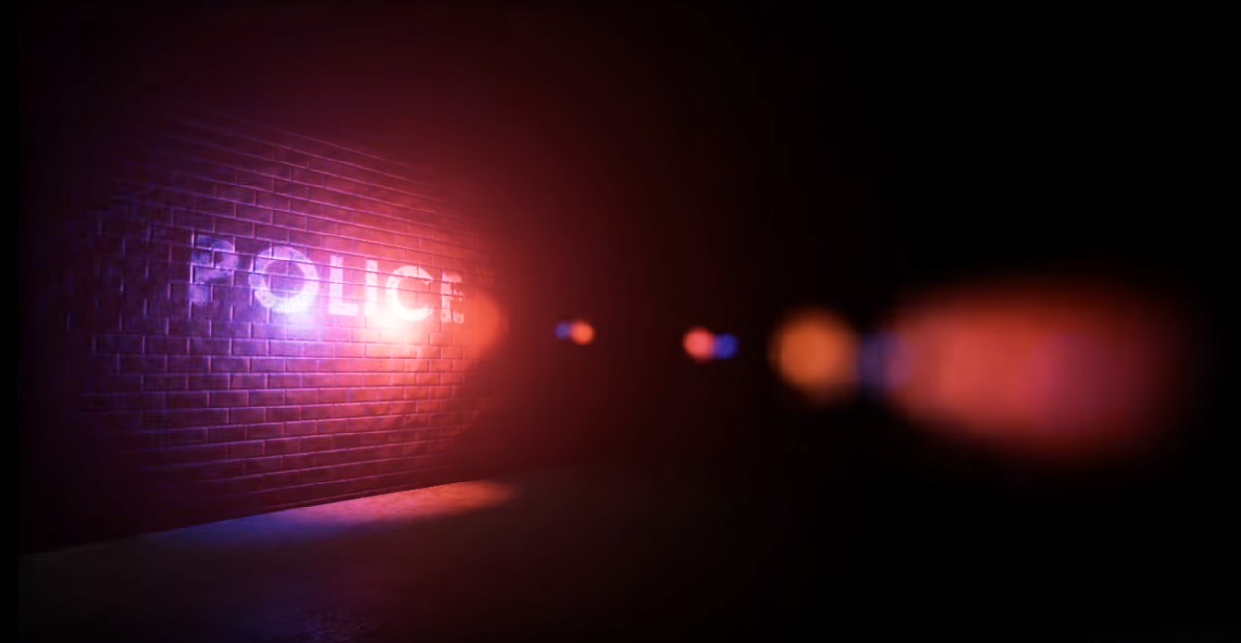
The setup for the computer simulation. The subject will be seated in front of a screen with the eye tracker below to watch them. | This picture shows an example of what our lights in the simulation look like currently.

Light Configurations
Below are the color configurations we are using for our experiments. These configurations were determined from our research on traditional New England color configurations used to date as well as those used by European agencies.
As previously stated, this project will focus on police vehicles. The lightbar on a police vehicles consists eight combinations of LED light arrays. as shown in the figure below. We have identified ten light configurations that we will use during our computer simulations that we will later down select into 3 or 4 configurations. Our configurations identify the color and the state of the lights (solid, flashing, blinking, strobing, etc.) and are designed to mirror similar configurations used by police vehicles today.
- R_{S}R_{S}R_{S}R_{S} R_{S}R_{S}R_{S}R_{S}
- B₁B₁B₂B₂ B₂B₂B₁B₁ -- France Configuration (https://www.youtube.com/watch?v=S5oLb6SkCTg)
- B_{F}B_{F}B_{O}B_{O} B_{O}B_{O}B_{F}B_{F} -- UK Configuration (https://www.youtube.com/watch?v=DllcuPOBl2I)
- R_{S}R_{S}R_{S}R_{S} B_{S}B_{S}B_{S}B_{S}
- R_{F}R_{F}R_{F}R_{F} B_{F}B_{F}B_{F}B_{F} -- Alternating lights
- R_{RB}B_{M}B_{M}B_{M} B_{M}B_{M}B_{M}R_{RB} -- Would light up blue from center towards end then flash red
- B_{RB}R_{M}R_{M}R_{M} R_{M}R_{M}R_{M}B_{RB}
- R_{F}B_{S}B_{S}B_{S} B_{S}B_{S}B_{S}R_{F}
- R_{M}R_{M}R_{M}R_{M} R_{M}R_{M}R_{M}R_{M} -- Sliding from one end to the other and back
- B_{M}B_{M}B_{M}B_{M} B_{M}B_{M}B_{M}B_{M}

Key:
S - Solid light, Always on
F - Flashing Light
M - Moving light
RB - Rapid Blink
O - Off
1 - Blinks first
2 - Blinks second
R - Red
B - Blue

Full-scale Simulation
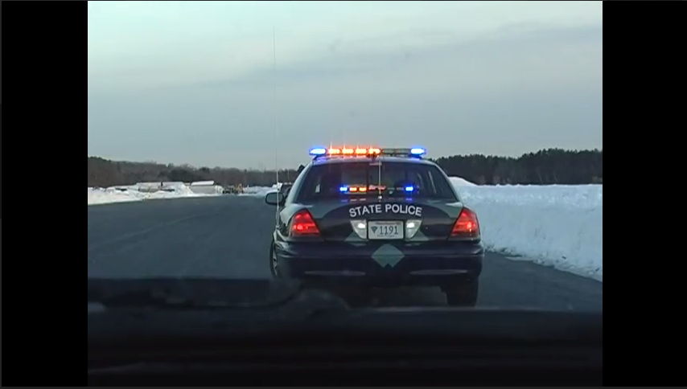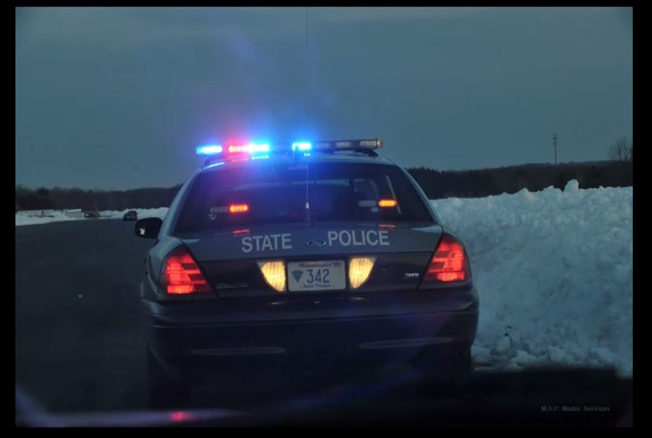
Whelen engineering provided us with videos of the experiments they conducted. Above are two screenshots taken from the video. Our full scale experiment will follow a similar structure. A Lightbar will be flashing on top of the road and the volunteer driver will approach the vehicle from 200 feet away. We will be observing their reactions and their eye movement as they approach the lightbar for 6 different flash patterns. We will be in the vehicle with the participants to track their eye movements and observe their reactions to the lightbar.

Full-scale Design
Originally we intended to buy all of the necessary components and create our own lightbar that simulated a modern emergency vehicle light bar. Upon further investigation and creating a Bill of Materials, we realized that the price tag for all of the components would go over our allotted budget. Instead, we contacted Scott Potter of Whelen Engineering and asked if we could borrow one of their light bars, which are used in actual emergency response vehicle all over the country. Mr. Potter offered to design, build and program a light bar for use in our full-scale simulation.
While we waited for the lightbar, we designed a prototype lightbar using LEDs and an Arduino Mega to simulate the light bar. Below is a segmented schematic of the prototype design:
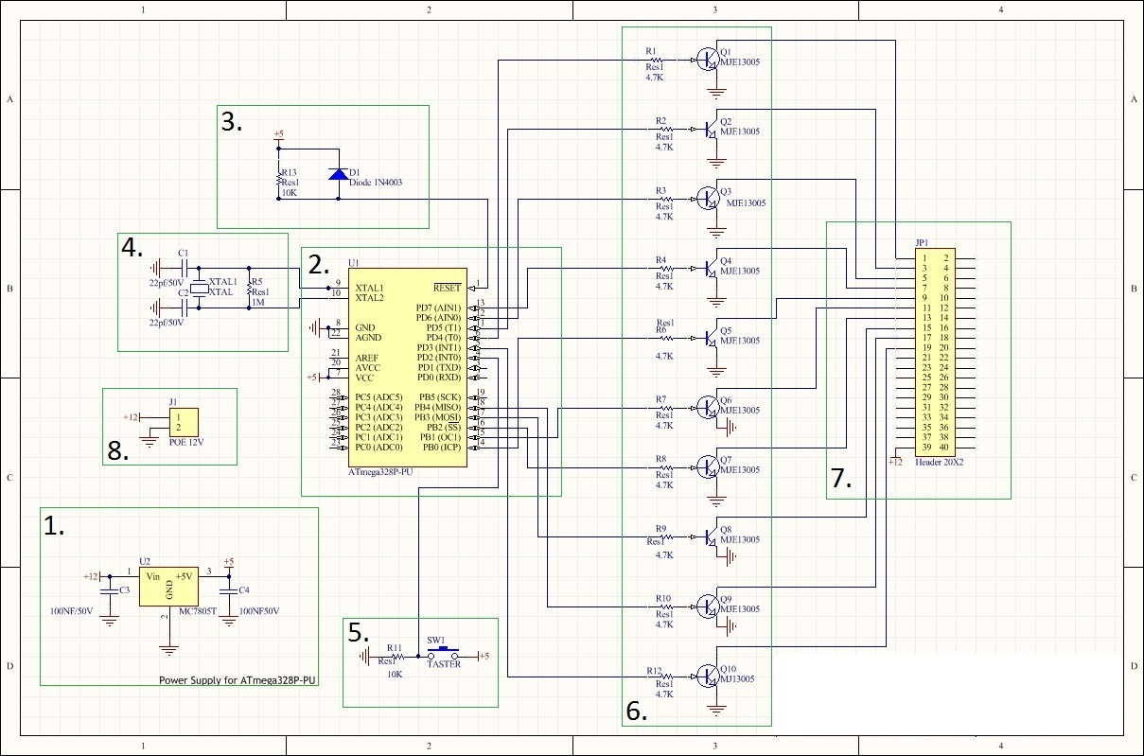
Segmented schematic of lightbar prototype

- Power Supply - We wanted the lightbar and the Arduino Mega to be powered by a DC power supply in order to be able to do the experiment in a secluded area without having to plug it into an AC outlet. We used the MC7805T as the voltage regulator and 100nF capacitors to smooth out the voltage ripple.
- Arduino Mega - We programmed the Arduino to contain 27 total flash patterns. A switch-case function was used to switch from one flash pattern to the next.
- Power-On Reset - The PoR is integral to any microcontroller design and comes on board the Arduino Mega circuit. This circuit ensures that a system or a device starts its operation when supply voltage stabilizes.
- Crystal Oscillator - A crystal oscillator is an electronic oscillator circuit that uses the mechanical resonance of a vibrating crystal of piezoelectric material to create an electrical signal with a precise frequency (i.e. 60 Hz).
- Switch Button - Switch button is connected to +5V from the Arduino Mega and to a 10K ohm pull-down resistor connected to GND. A debounce function was created in the Arduino program to prevent the program from detecting mechanical bounce from the switch button.
- Transistor - The common-emitter transistor is designed to regulate the 12V from the power supply down to a usable 5V for the microcontroller and the LEDs.
- Header - This is used to connect the LEDs from the supply to Arduino. I ultimately removed it from my design and used jumper wire instead.

Arduino Code
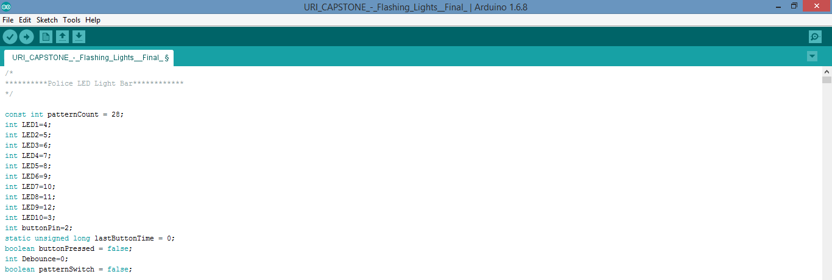
This part of the code initializes all of the variable names and values
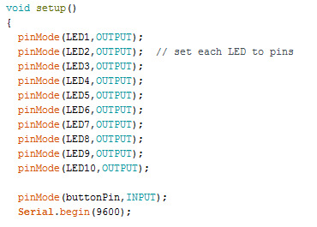
Pins on the Arduino board are assigned as either inputs or outputs

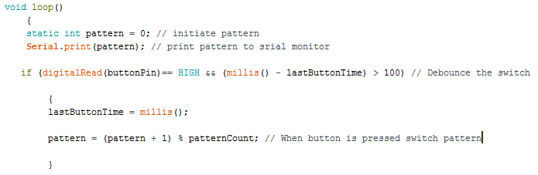
This loop debounces the switch and switches patterns when the switch button is pressed. The count resets to 0 after the user switches through all of the configurations.

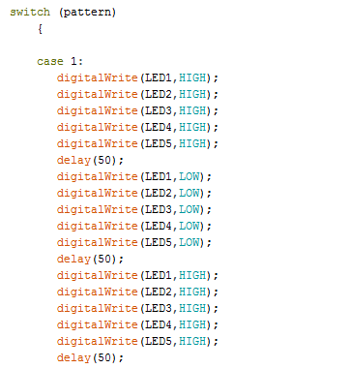
The switch-case function makes it easy to edit and decide the order of the flash patterns. The delays determine the frequency of the flashing.

Whelen Edge Freedom Series Lightbar
The purpose of designing a prototype was to connect the Arduino circuit to the full size lightbar instead of the LEDs. However, we did not anticipate the Whelen lightbar to require +12V and 25A. That amount of current draw is way too much to handle and would destroy the Arduino Mega. We decided to drop the prototype design and instead use the Power Control Center and Control module given to us by Whelen. We used Whelen Engineering’s user-friendly WeCan 6 program to change the flash patterns on the lightbar. Instead of writing code like in the Arduino, WeCan 6 uses pictures and drop-down menus to edit the lightbar. We used the same six configurations as in the Highway driving simulation.

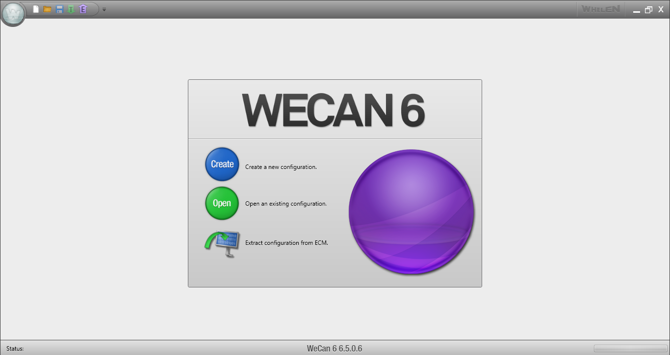
WeCan 6 start screen: Decide whether you would like to Create a new configuration, open an existing file or download the configuration from an existing light bar.

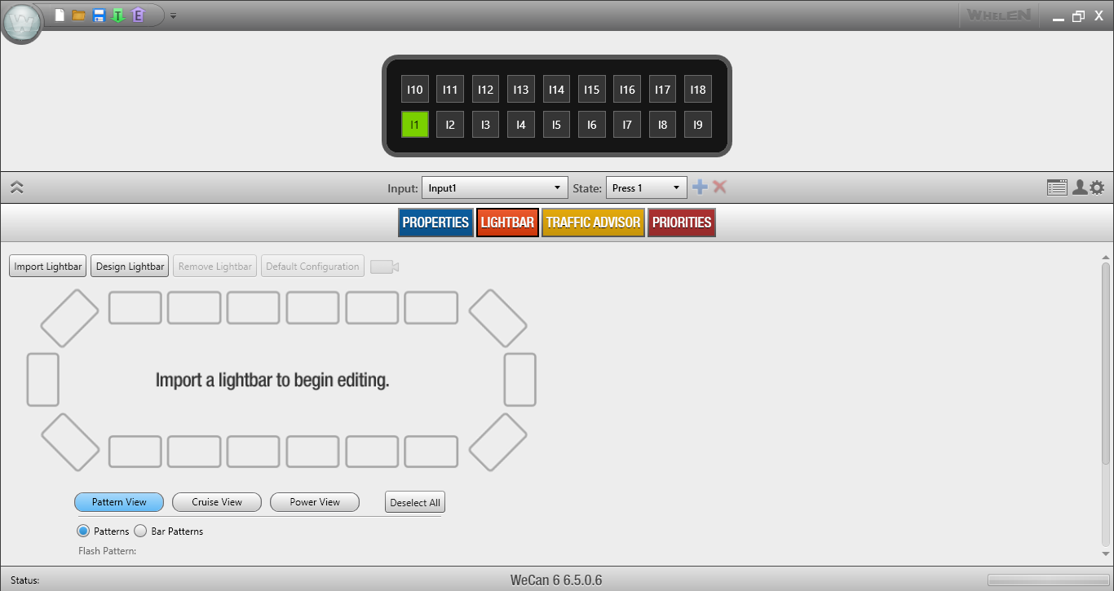
WeCan 6 Lightbar Editor: Select color and properties of each segment as well as edit the frequency and intensity of the lights

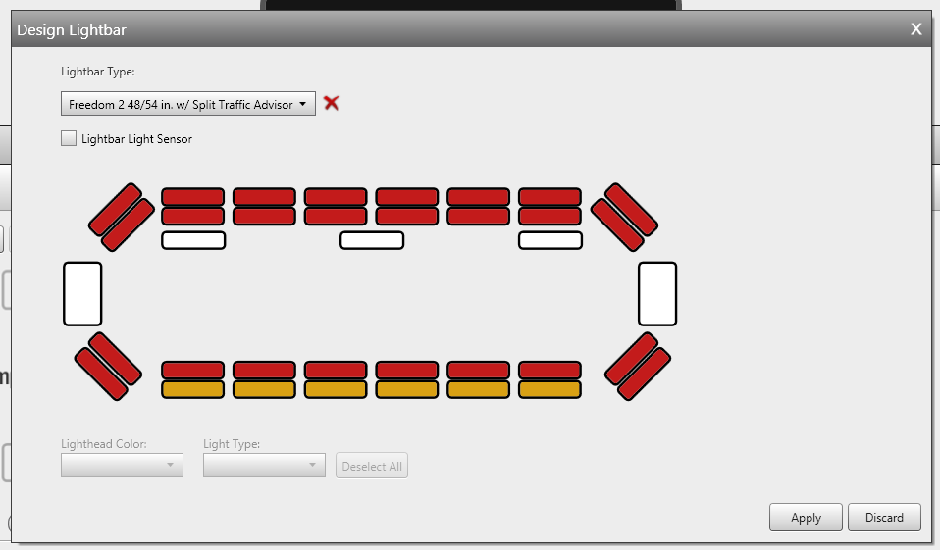
WeCan 6 Color Select: Choose between red, blue, amber and white. Duo light bars have ability to have two rows of different colors.

ABET OUTCOME C

The number one concern in any engineering project is safety. The irony in our project is that an emergency responders duty is to save lives and keep the public safe, but their very own LED lights have contributed to the rise of highway accidents. Due to these dangers, we carefully considered every safety concern before starting any of our experiments. Also, though we would like to make our experiments as realistic and accurate as possible, economic constraints prevented us from doing so.
We addressed many of our safety concerns early on in our project and designed constraints in our experiments to minimize risk of injury or discomfort. The first concern we addressed was avoiding the possibility of our subjects having epilepsy, because flashing red and blue lights can cause subjects to a seizure at frequencies between 10 Hz and 20 Hz. Before we began any of our experiments, we handed our subjects questionnaires where they input their personal information. One of our questions asked whether the subject has epilepsy or has ever had a seizure. If the answer to this question was yes, the subject was not allowed to participate in our study. Another safety concern for our project was whether or not our subject was legally able to drive. Before starting the full-scale simulation, we would ask each subject to prove that they had a valid driver’s license. Lastly, although it would have greatly supported our hypothesis, we avoided the simulation of impaired driving. During the research phase of our experiment, we found Drunk Vision goggles which simulate the effect of being impaired. Being able to simulate drunk driving would be helpful in determining whether LED lights cause phototaxis (moth-to-flame effect) in impaired driving. The safety of our test subjects was more important to us than the conclusiveness of our experiments so we decided against using the Drunk Vision goggles.
The economic constraints of our project prevented us from creating the best possible experiments to test our hypothesis. For example, the eye tracker we used for our simulations was the cheapest one we could find. It did not have the accuracy or the user-friendliness of other eye trackers on the market. A preferable but more expensive option for eye tracking software would be Augmented Reality (AR) goggles that come with live video feed as well as heat maps to represent the movement of the user’s eyes, We were unable to use our eye tracker during our full-scale simulation because the eye tracker needed to remain still. With AR goggles, the driver could just wear the goggles during the experiment. Another thing that could have been improved with a bigger budget is the simulation software used. The Unreal Engine 4 is free and easy to use, but it is not as accurate or realistic as other more expensive options in the market. However, for the purposes of a college-level Capstone project, our budget was able to meet our needs.

Major Milestones until December 14, 2015

Research Phase:
- Create a case for the project using research gathered
- Develop experimental design
- Down select candidate light configurations
- Perform preliminary test setups
- Decide on how to analyze and record data
- Write an article for a magazine (i.e. APA, SAE, Fleet, etc.)
- Complete a computer driving simulation using Unreal Engine
- Determine plan for building/designing/programing full-scale light bar

Major Milestones for January to April 2016

Computer Simulation Phase:
- Paired Comparison Test (six participants from Capstone class)
  - Familiarize ourselves with the 'human factors' phenomenon of flashing lights,
  - Familiarize ourselves with the test setup
  - Familiarize ourselves with objective measurement of human behavior (using the eye tracking device)
  - Develop subjective measurement instruments (questionnaires, Likert scales, interviews with subjects), and dependent variables (time on target)
- Analyze findings and reduce the number of light configurations
- Create a functioning simulation of the a police car on the side of the road using Unreal Engine 4 (Highway Awareness Simulation)
  - Subject will be in a virtual moving vehicle
  - The hypothesis is that the more distracting the light bar configuration, the less likely the subjects will remember the scrolling messages displayed since they are 'attracted' to the light bar lights.
  - The optimal configuration is one in which the subjects remember all of the test messages and can identify or describe what they saw on the shoulder of the road (ie. what color were the lights, they knew what the lights represented.)
- Perform surveys and interviews on participants
- Analyze data

Full Scale Simulation Phase:
- Determine 6 light configurations to test
- Build a portable power supply
- Program an Arduino Mega to program the light configurations for the Whelen Legacy Lightbar
- Perform full scale simulation
- Run questionnaires and interviews
- Analyze Data
- Report Data (Article) and provide recommendations

Overall Linear Responsibilities Chart

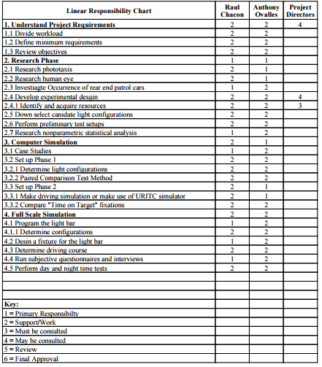

Summary of My Technical Responsibilities

Raul Chacon
- Developing the hardware and the software interfaces for the various stages of our project.
- Developing timing circuits and full scale light packages
- Assisting Anthony with developing a user-friendly computer simulation
- Program a light bar to match our computer simulation in order to conduct experiments in full-scale driving conditions.

Anthony Ovalles
- Research information on the human eye
- Create a comparison test simulation for different light configurations
- Create a computer simulation that sets the scenario of a police car on the side of the road while the subject is traveling past it
- Set up eye tracker to record “Time on Target” data
- Retrieve the data from the eye tracker software

My Individual Technical Contributions to-date

Raul Chacon
- Existing research on flashing lights on emergency vehicles (US and Europe),
- Gathered knowledge on nonparametric and parametric statistical analysis
- Statistics on accidents caused by emergency vehicle flashing lights in New England.
- Created experiment design with data tables and light configurations (with Anthony)
- Designed an analysis for our experiments
- Responsible for marketing experiment and finding volunteers
- Writing article about our project for a magazine
- Obtained lightbar from Whelen Engineering
- Relearned how to program an Arduino
- Building a harness and stand for Whelen lightbar
- Designing a portable 12-V power supply for lightbar
- Attaching Power Control Center and Control Module to Whelen Lightbar
- Editing WeCan 6 Program to match Highway Driving Simulation

Anthony Ovalles
- Research on phototaxis and dark adaption
- Made request for the order of the eye tracker
- Downloaded engine for design of computer simulation
- Created a Blueprint, the coding language, for the lights in the simulation
- Created all 10 configurations of the light bar for the virtual simulation
- Created a user friendly GUI to access the configurations
- World Creation started for full virtual simulation.
- Completed virtual simulation program
- Gather data using eye tracking software and determined time off target

References
State Statutes (RI & Mass):
http://www.extremetacticaldynamics.com/knowledge-base/state-statutes/rhode-island/
http://www.extremetacticaldynamics.com/knowledge-base/state-statutes/massachusetts/

Approved LED Deck Lights (RI):
http://www.911signalusa.com/led-deck-light-model-f61-p-73.html

URITC Car Simulator:
http://www.uri.edu/uritc/media/workforce_development/Driver%20Simulator.pdf

Similar Experiments
Cook, Sharon; Claire Quigley; Laurence Clift (March 2000). "Motor vehicle and pedal cycle conspicuity: part 1- vehicle mounted warning beacons. Summary report.". DfT Report; PPAD 9/33/13. Loughborough University.

Phototaxis and Looming:
http://www.visualexpert.com/Resources/motheffect.html
https://www.usfa.fema.gov/downloads/pdf/publications/fa_323.pdf
http://digitalcommons.apus.edu/cgi/viewcontent.cgi?article=1018&context=theses

Light/Dark Adaptation:
http://www.cns.nyu.edu/~david/courses/perception/lecturenotes/light-adapt/light-adapt.html
https://www.youtube.com/watch?v=Hd5dCkxXzkU
http://www.chm.bris.ac.uk/webprojects2003/white/light_and_dark_adaptation.htm
"Sensory Reception: Human Vision: Structure and Function of the Human Eye" Encyclopædia Britannica, vol. 27, 1987

EYE Tracking software
http://dev.theeyetribe.com/general/#use_cases
https://theeyetribe.com/products/

Purchasing components
http://www.digikey.com/en

Drunk Vision Impairment Goggles
http://www.drunkbusters.com/product-info.php?impairment-goggles-pid1.html
Sheila G. Mitchell, R.N. (URI Health Education)
c: 401-874-5149

Nonparametric and Parametric Analysis, Normal Distribution, Statistics
Professor Piserchia (Computer Science and Statistics)
e: mvpiserchia@gmail.com
r: Tyler 128

Whelen Lightbar and WeCan 6
www.whelen.com/index.php
https://www.youtube.com/channel/UCkYNIIOdmzDedxSM35pZH4A

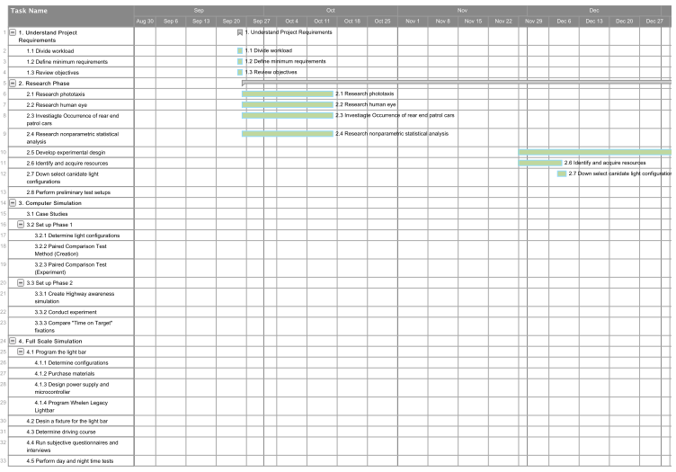
Appendix A: Updated Gantt Chart

Appendix A: Updated Gantt Chart (Cont.)
